# IT 230 Coding Activity Submission Template

Submit your work on the coding activities for Modules One, Two, Three, Four, and Six in this document. In addition to this document, you should submit a ZIP file containing all your Visual Studio project files and source code that can be run in Visual Studio on a different computer.

For each coding activity, complete the following steps:

* Download and rename this document to meet the file naming conventions requested in the assignment instructions.
* Fill in the required information below by replacing the bracketed text with the relevant information.
* Submit this document and your ZIP file for grading and feedback. Your ZIP file should follow the same naming conventions.

Document your work in the coding activity by completing each of the following items:

1. Provide a screenshot of the output that resulted from running your program successfully in Visual Studio. See the coding assignment instructions for an example of what should be included in the screenshot. Your screenshot must include the following elements:
   1. Your last name as the first printed text on the screen
   2. Verification that the program is fully functioning and data results are accurate for the given problem

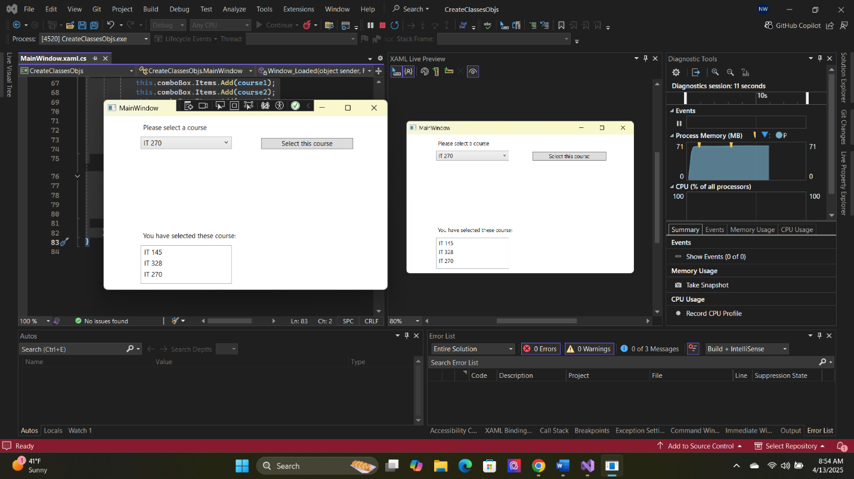

1. Copy and paste the source code text you wrote for this assignment from the *.cs file into the space below. Only providing the *.cs files or a screenshot does not meet the requirements for this part of the assignment. Code should be logically organized. It should also follow proper syntax and conventions noted in the Coding Activity Guidelines and Rubric.

namespace CreateClassesObjs

{

class Course

{

public string name;

public void setName(string userChoice)

{

name = userChoice;

}

public string getName()

{

return name;

}

public override string ToString()

{

return getName();

}

}

/// <summary>

/// Interaction logic for MainWindow.xaml

/// </summary>

public partial class MainWindow : Window

{

Course choice;

public MainWindow()

{

InitializeComponent();

}

private void Window_Loaded(object sender, RoutedEventArgs e)

{

Course course1 = new Course();

Course course2 = new Course();

Course course3 = new Course();

Course course4 = new Course();

Course course5 = new Course();

Course course6 = new Course();

Course course7 = new Course();

course1.setName("IT 145");

course2.setName("IT 200");

course3.setName("IT 201");

course4.setName("IT 270");

course5.setName("IT 315");

course6.setName("IT 328");

course7.setName("IT 330");

this.comboBox.Items.Add(course1);

this.comboBox.Items.Add(course2);

this.comboBox.Items.Add(course3);

this.comboBox.Items.Add(course4);

this.comboBox.Items.Add(course5);

this.comboBox.Items.Add(course6);

this.comboBox.Items.Add(course7);

}

private void button_Click(object sender, RoutedEventArgs e)

{

choice = (Course)(this.comboBox.SelectedItem);

this.listBox.Items.Add(choice);

}

}

}

1. Show that you understand the task by explaining the design of your program in the space below. Include the process and steps you took to write your code. Explain how you arrived at the solution to the problem and completed the activity.

I struggled a lot with this assignment. I was adding elements that didn’t need to be there yet for this assignment. All that needed to be done with this was to add a Course class and make sure it worked with the rest of the code. After a few hours I finally got what I needed done and it only took a bit of studying.

1. Reflect on your learning experience and what you learned from completing the activity.

I gained more practice in though process more than I did in learning code. I kept trying to add more than I needed and this was halting me. I needed to pay more attention and think about what needed to be completed than what I thought was supposed to be done.